Name : Arga yudha adhiprama

Nim : L200134003

Class : informatics ( 4 ) / semester

**Assingment of Mobile Programming**

1. Client Problem Statement

Need to have you make a application about information of country use a android application, which to enable to looking information in the country like a name central of city, and name continent, wide , birth of country , and name of many .

# summary

1. make application about information of country

2. based application is android application

3. the application provide information like name central of city, name continent, wide, birth of country, and name of many.

2. DVD Level 0

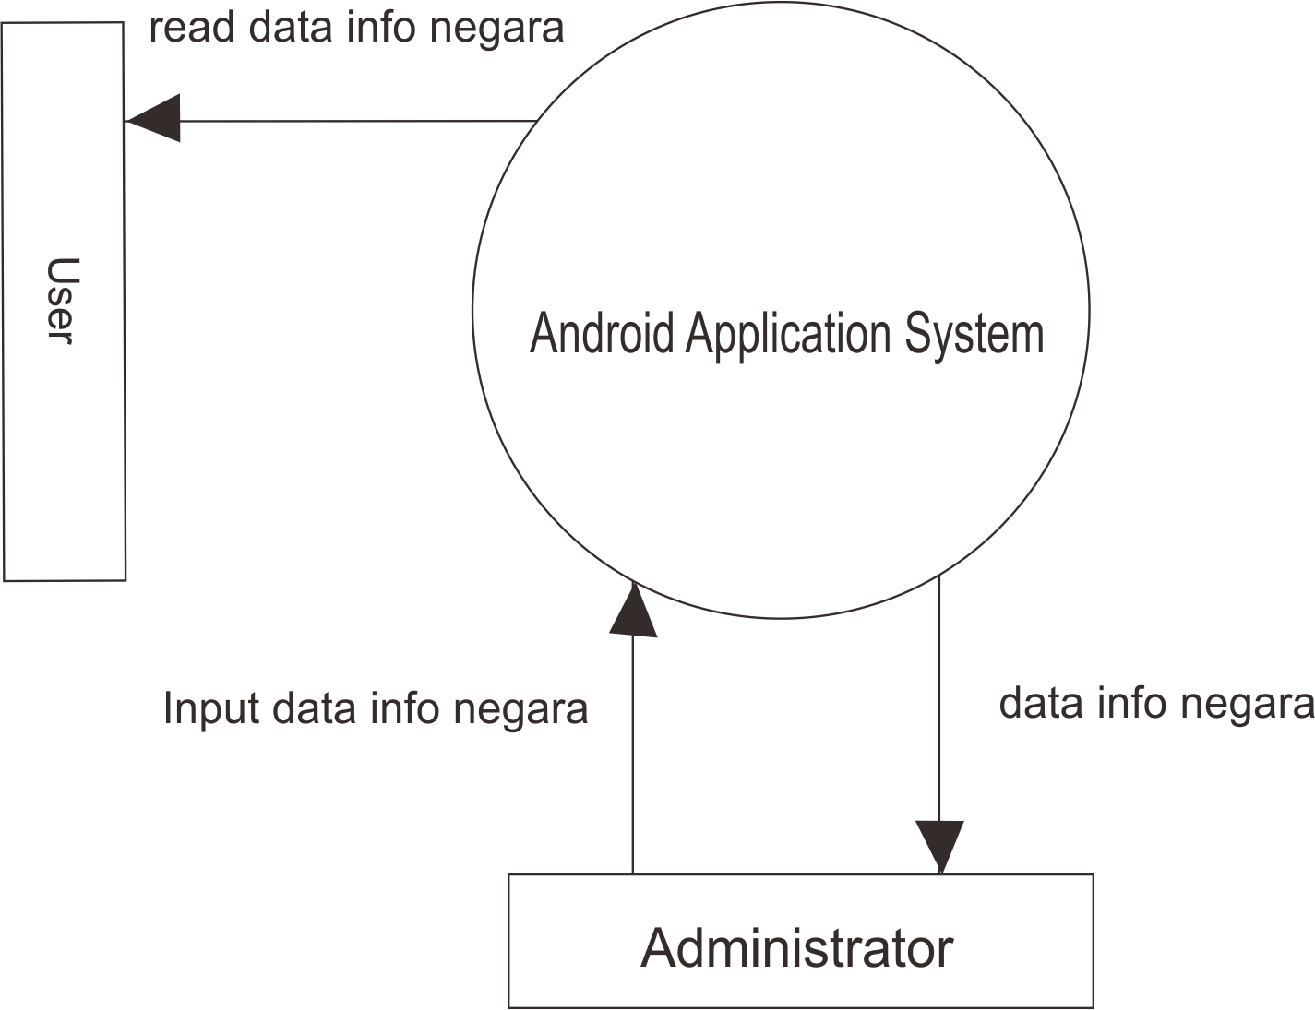

3. Use Case Diagram

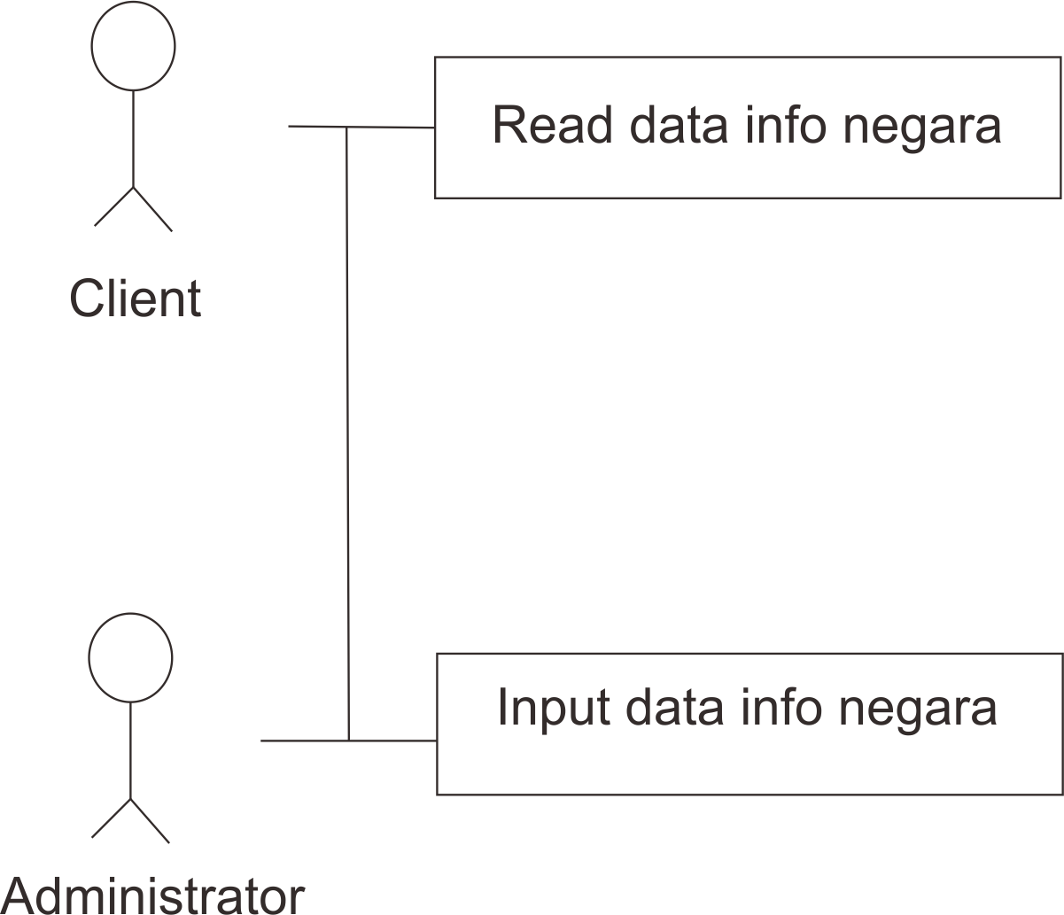

4. How the system work

The system will be work if client open the application and choose flag of country and push the flag so will be move in page description of the country accordinbg the flag, if you want to back in menu you just click botton tutup and back to menu and you can choose another flag of country and looking the description.